- Reapportionment and redistricting

- reapportionment: The allocation of seats in the House to each state after the census. (depending on how your state’s population changes, your state could get another seat or lose a seat)

- Redistricting: Redistricting is the process of redrawing district boundaries when a state’s population increases or decreases.
According to law only 435 seats in Congress, so if population increases in Texas, they gain a new seat. If population decreases in Michigan, they lose a seat. Population in each of the 435 congressional districts must be roughly equal (right now about 750,000 people per district).
- When does redistricting occur?
Redistricting occurs every ten years, with the national census.
- Why does the US House have to be redistricted?
The United States Constitution requires congressional seats to be reapportioned among the states after each decennial census. Because the Supreme Court in the 1960s interpreted the Constitution to require that each House district have equal numbers of people, any state with more than one district must adjust its district lines.
- Who is in charge of redistricting?
In most states (34 out of 50) state legislatures re-draw the boundaries of the US House districts. You see problems here? Explain. Think political party.

- In 34 states, the state legislature has primary responsibility for creating a redistricting plan, in many cases subject to approval by the state governor. To reduce the role that legislative politics might play, six states (Arizona, California, Hawaii, Idaho, New Jersey and Washington) determine congressional redistricting by an independent or bipartisan redistricting commission.^{[1]} Three states, Florida, Iowa and Maine, give independent bodies authority to propose redistricting plans, but preserve the role of legislatures to approve them. Seven states have only a single representative for the entire state because of their low populations; these are Alaska, Delaware, Montana, North Dakota, South Dakota, Vermont and Wyoming.
Gerrymandering: is the practice of drawing district lines to achieve political gain for the legislators in a political party. The practice of gerrymandering involves the manipulation of district drawing in aims to leave out, or include, specific populations in a legislator's district to ensure his/her reelection.
The drawing of a legislative districting boundary lines for the purpose of obtaining partisan or factional advantage. A district is said to be gerrymandered when its shape is manipulated by the dominant party in the state legislature to maximize electoral strength at the expense of the minority party.
a “majority -minority” district is: Gerrymandered districts created to make sure a minority group is the majority in a district so that group gets a rep in Congress. Originally the majority-minority districts were set up so states could comply with the Voting Rights Act of 1965. SCOTUS has ruled these districts unconstitutional.

SAFE SEATS ARE CREATED…many House seats are safe seats now because of gerrymandering (i.e. one party gets more constituents in that district then that rep can almost be assured of reelection).

Restrictions SCOTUS has placed on Congressional Redistricting:
- Districts must be roughly equal in size.
- Districts can not dilute race.
- Districts cannot use race as the sole reason for redistricting; race can only be used as one of several factors.
- Districts must be compact.
- Districts must be contiguous.
Map of Florida gerrymandered district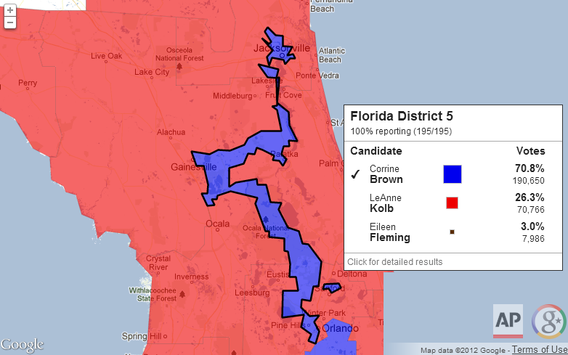
TN U.S. Congress district map: 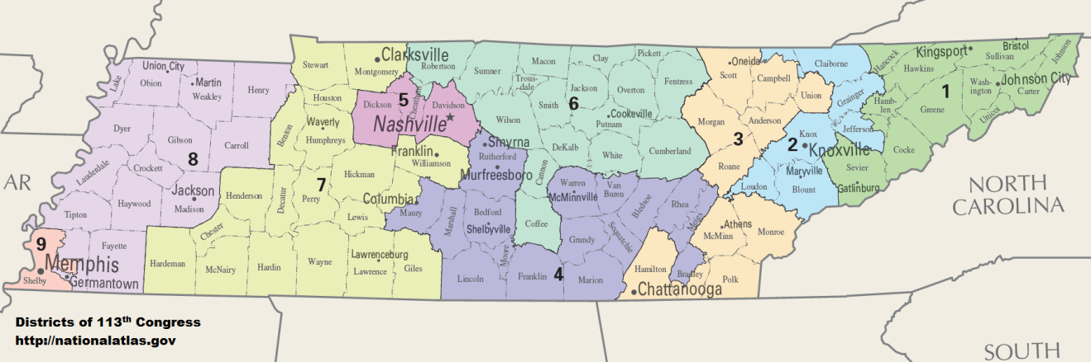
- SCOTUS Case (one of the 15 must-know cases)
Shaw v. Reno (1993)
Argued: April 20, 1993
Decided: June 28, 1993
Background
After the Civil War, the 13th, 14th, and 15th Amendments ended slavery, granted citizenship to formerly enslaved persons, and gave African-American men the right to vote. Soon thereafter, state governments, primarily in the south, institutionalized black codes and Jim Crow laws to prevent former slaves from voting. Poll taxes, literacy tests, and felon disenfranchisement were among the practices commonly used to suppress black voting.
In order to prevent states from suppressing the right of African-Americans and other minorities to vote, Congress passed the Voting Rights Act in 1965. This law prohibited voting rules that discriminated on the basis of race. The law also placed cities, counties, and states with a history of discriminatory practices in a special category. These jurisdictions had to request pre-clearance from the federal government before changing their voting rules and were required to prove that the proposed change did not limit a person’s right to vote because of their race. The courts concluded that the Voting Rights Act, including this “pre-clearance” requirement, applied to the drawing of legislative district boundaries, which each state must do every 10 years to account for changing populations. While states generally can adopt their own criteria for districting—which typically include making districts that are reasonably compact and contiguous (where all parts of the district are connected to one another) and that align with existing geographical boundaries like cities or counties—they may not draw districts in a way that discriminates on the basis of race.

Facts
Between 1865 and 1993, the state of North Carolina elected only seven African-Americans to the U.S. House of Representatives. In 1990, none of the state’s 11 members of Congress were black, while 20% of the state’s population was. After the 1990 census, the state gained a 12th Congressional seat, and the state legislature tried to ensure the election of an African-American representative through the creation of a legislative district that would be majority African-American. Forty of North Carolina’s counties were covered by the Voting Rights Act requirement that redistricting plans be pre-cleared by the federal government, so the state submitted its plans to the U.S. Department of Justice. The attorney general rejected the North Carolina state legislature’s first redistricting plan because it created only one majority-minority district. The Department of Justice said that a second majority-minority district could also be created.
The General Assembly (North Carolina’s legislature) redrew the district lines to create a second majority-minority district, District 12. District 12 ran along Interstate 85 in snake-like fashion for 160 miles, breaking up several counties, towns, and districts to connect geographically separate areas densely populated by minority voters into a single district that, in some places, was only as wide as the highway. The attorney general did not object to this new districting plan. In 1992, Melvin Watt won the 12th district, becoming one of North Carolina’s first two black members of Congress in the 20th century.
Five white voters filed a lawsuit against both state and federal officials in the U.S. District Court for the Eastern District of North Carolina. They argued that District 12 violated the 14th Amendment’s Equal Protection Clause because it was motivated by racial discrimination and resulted in a district drawn almost entirely on racial lines, with the sole purpose of electing black Congressional representatives. The District Court dismissed the case, concluding that using race-based districting to benefit minority voters does not violate the Constitution. The voters appealed to the Supreme Court, which is required by law to hear most redistricting cases.
Issue
Did the North Carolina residents’ claim that the 1990 redistricting plan discriminated on the basis of race, which raised a valid constitutional issue under the 14th Amendment’s Equal Protection Clause?
North Carolina U.S. Congressional District 12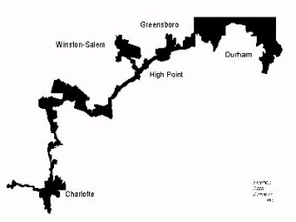

Constitutional Amendments and Supreme Court Precedents
- 14th Amendment to the U.S. Constitution
“Nor shall any state…deny to any person within its jurisdiction the equal protection of the laws.”
- 15th Amendment to the U.S. Constitution
“The right of citizens of the United States to vote shall not be denied or abridged by the United States or by any State on account of race, color, or previous condition of servitude.”
- Article III, section 2 of the U.S. Constitution
“The judicial Power shall extend to all Cases, in Law and Equity, arising under this Constitution, the Laws of the United States, and Treaties made, or which shall be made, under their Authority. . . .”

Arguments for Shaw (petitioner)
- The Constitution is “color-blind,” meaning it prohibits using race as the basis for how to draw districts. This redistricting plan is the opposite of color-blind and amounts to unconstitutional discrimination on the basis of race.
- The snake-like shape of District 12 makes it neither compact nor truly contiguous, which are the traditional criteria for district maps. The legislature’s obvious disregard for these criteria confirms that its sole purpose was to create a seat to represent a particular racial group.
- In Gomillion v. Lightfoot (1960), the Court held that dividing voters into districts on the basis of their race is impermissible racial segregation. That does not change just because race is used to advance the interests of a minority group rather than limit them.
- Drawing districts on the basis of race advances the stereotype that black voters will only vote for a black candidate and white voters for a white candidate. Minority voters have different views and interests, and do not necessarily have a single, unified “candidate of choice.”
Arguments for Reno (respondent)
- The courts have ruled that the use of race in redistricting is permissible and might even be more important than traditional districting features such as contiguousness and compactness, as long as the configurations are not too extreme. Oddly shaped districts are sometimes necessary if states are to elect representatives who are reflective of the people of the state.
- The Voting Rights Act of 1965 encourages the creation of districts with majorities of black, Hispanic, and other minority voters, especially where there has been voting discrimination in the past.
- In Gomillion v. Lightfoot (1960), the Court held that districts can’t be drawn to discriminate against minorities. But that does not mean that race can’t be used to draw districts that advance the interests of minorities.
- In United Jewish Organizations of Williamsburgh, Inc. v. Carey, the Court approved “racial redistricting where appropriate to avoid abridging the right to vote on account of race.” Though whites had lost one legislative seat as a result of redistricting, the Court found that their constitutional rights were not violated because they were not deprived of effective representation or the right to vote.
Decision
In a 5–4 decision, the U.S. Supreme Court decided in favor of Shaw, and North Carolina was forced to redraw its congressional map.
Majority
Justice O’Connor detailed the troublesome history of racial gerrymandering and explained how North Carolina District 12 was similar in many ways to past districts that had been held unconstitutional. The justices said that classifications of citizens predominantly on the basis of race are undesirable in a free society and conflict with the American political value of equality.
The majority said that any redistricting plan that includes people in one district who are geographically disparate and share little in common with one another but their skin color, bears a strong resemblance to racial segregation. They wrote that racial classifications of any sort promotes the belief that individuals should be judged by the color of their skin. They also said that drawing districts to advance the perceived interests of one racial group may lead elected officials to see their obligation as representing only members of that group, rather than their constituency as a whole. The justices concluded that racial gerrymandering, even for remedial purposes, may “balkanize us into competing racial factions; it threatens to carry us further from the goal of a political system in which race no longer matters.”
The Court was tasked with deciding the grounds on which voters could challenge voting districts as racial gerrymanders. They decided that if a redistricting plan cannot rationally be understood as anything other than an effort to divide voters based on their race, voters may challenge such a district under the Equal Protection Clause.
Dissents: In a series of separate dissents, the dissenters argued that consideration of race in the districting process is inevitable, and that it does not violate the Constitution unless the party challenging a district shows that the district was drawn in a way that deprives a racial group of an equal opportunity to participate in the political process. Some of the dissenters also argued that there are legitimate reasons to consider race because people of the same race share interests and often vote together, and that race-conscious gerrymandering only violates the Equal Protection Clause if the purpose of those drawing the boundaries is to enhance the power of the group in control of the process, at the expense of minority voters.

- Other nomenclature relating to the legislative process

A. Incumbents -the person who currently hold the office in the election for that office
-incumbents frequently win because of “credit-claiming” (i.e. “I voted for the tax cut law”, or “I voted for the healthcare law), more access to money for advertising, and a track record of service to their constituents (see third column).

B. Caucuses: Also, senators and representatives are also members of caucuses (this is different from caucuses that serve to nominate a candidate for a general election). A caucus is a group of legislators who share a similar aim or interest (examples are The Republican Caucus, the Democrat Caucus, the Black Caucus, the Women’s Caucus, the Hispanic Caucus, the potato caucus, the citrus fruit caucus, etc.
C. Congresspersons are also constantly pressured to vote a certain way by the following:
-colleagues through logrolling
-PACs try to influence votes through contributions to congresspersons campaigns for re- election as do constituents and interest groups.
- personal ideology and religious beliefs
BUT: THE MOST IMPORTANT FACTOR IN DETERMINING THE VOTE OF A CONGRESSPERSON IS PARTY AFFILIATION. MEMBERS OF CONGRESS USUALLY, BUT NOT ALWAYS VOTE WITH THEIR PARTIES.
-PACs: Political Action Committee (PAC) — A popular term for a political committee organized for the purpose of raising and spending money to elect and defeat candidates. Most PACs represent business, labor unions, or ideological interests. There are limits on the amount of money a PAC can donate to a candidate’s campaign, or a political party.
-Super PACS: A type of PAC that by law cannot make contributions to candidates or parties. They do, however make independent expenditures in federal races - running ads or sending mail or communicating in other ways with messages that specifically advocate the election or defeat of a specific candidate. There are no limits or restrictions on the sources of funds that may be used for these expenditures, AND no limits on the amount of money they can spend!

Super PACS: PACs make no contributions to candidates or parties. They do, however make independent expenditures in federal races - running ads or sending mail or communicating in other ways with messages that specifically advocate the election or defeat of a specific candidate. There are no limits or restrictions on the sources of funds that may be used for these expenditures. These committees file regular financial reports with the FEC which include their donors along with their expenditures.
Super PACs
Technically known as independent expenditure-only committees, Super PACs may raise unlimited sums of money from corporations, unions, associations and individuals, then spend unlimited sums to overtly advocate for or against political candidates.
A super PAC is a relatively modern breed of political-action committee that is allowed to raise and spend unlimited amounts of money from corporations, unions, individuals and associations.
The term "super PAC" is used to describe what is technically known in federal election code as an "independent expenditure-only committee.
The most important difference between a super PAC and traditional candidate PAC is in who can contribute, and in how much they can give.
Candidates and traditional candidate committees can accept $2,500 from individuals per election. That means they can take in $5,000 a year - half in the primary, and half in the general election.
Candidates and traditional candidate committees are prohibited from accepting money from corporations, unions and associations. Federal election code prohibits those entities from contributing directly to candidates or candidate committees.
Super PACs, though, have no limitations on who contributes or how much they contribute. They can raise as much money from corporations, unions and associations as they please and spend unlimited amounts on advocating for the election or defeat of the candidates of their choice.

Are there any restrictions on super PACs?
Yes. The most important restriction prohibits super PACs from working in conjunction with the candidates they're supporting. According to the Federal Election Commission, super PACs cannot spend money “in concert or cooperation with, or at the request or suggestion of, a candidate, the candidate's campaign or a political party.”
- Citizens United v. FEC (2010): essential, must-know case
Argued: March 24, 2009
Reargued: September 9, 2009
Decided: January 21, 2010
Background
Each election cycle billions of dollars are spent on congressional and presidential campaigns, both by candidates and by outside groups who favor or oppose certain candidates. Americans disagree about the extent to which fundraising and spending on election campaigns should be limited by law. Some believe that unlimited fundraising and spending can have a corrupting influence—that politicians will “owe” the big donors who help them get elected. They also say that limits on fundraising and spending help make elections fair for those who don’t have a lot of money.
Others believe that more spending on election campaigns supports broader debate and allows more people to learn about and discuss political issues. Those supporting more spending say that giving and spending money on elections is a basic form of political speech protected by the First Amendment.
Over the past 100 years, Congress has attempted to set some limits on campaign fundraising in order to reduce corruption or anything that can be perceived as corruption.
The Supreme Court has decided that both donating and spending money on elections is a form of speech. For candidates, the money pays for ways to share his or her views with the electorate—through advertisements, mail and email, and travel to give speeches. For donors, giving money to a candidate is a way to express political views. Therefore, any law that limits donating or spending money on elections limits free speech, and the government must have a very good reason for making such laws.
The Supreme Court has ruled that laws that restrict how much candidates can spend on a campaign are unconstitutional, since candidates spend money to get their message out, which is a very important form of political speech. However, the Court has said that laws that restrict how much individuals and groups can donate directly to candidates are allowed, because that spending is slightly removed from core political speech, and such laws can prevent corruption. In 2018, the maximum amount an individual could give directly to a federal candidate was $2,700.
This case, however, is not about direct donations to candidates. Instead, this case is about how and when companies and other organizations can spend their own money to advocate the election or defeat of a candidate.
Facts
One of the federal laws that regulates how election money can be raised and spent is the Bipartisan Campaign Reform Act (BCRA), also known as the McCain-Feingold Act. Passed in 2002, one part of this law dealt with how corporations and unions could spend money to advocate the election or defeat of a candidate. The law said that corporations and unions could not spend their own money on campaigns. Instead, they could set up political action committees (PACs). Employees or members could donate to the PACs, which could then donate directly to candidates or spend money to support candidates. The law prohibited corporations and unions from directly paying for advertisements that supported or denounced a specific candidate within 30 days of a primary election or 60 days of a general election. It is this part of the BCRA that is at issue in Citizens United v. Federal Election Commission.
In 2008, Citizens United, a non-profit organization funded partially by corporate donations, produced Hillary: The Movie, a film created to persuade voters not to vote for Hillary Clinton as the 2008 Democratic presidential nominee. Citizens United wanted to make the movie available to cable subscribers through video-on-demand services and wanted to broadcast TV advertisements for the movie in advance. The Federal Election Commission said that Hillary: The Movie was intended to influence voters, and, therefore, the BCRA applied. That meant that the organization was not allowed to advertise the film or pay to air it within 30 days of a primary election. Citizens United sued the FEC in federal court, asking to be allowed to show the film. The district court heard the case and decided that even though it was a full length movie and not a traditional television ad, the film was definitely an appeal to vote against Hillary Clinton. This meant that the bans in the BCRA applied: corporations and organizations could not pay to air this sort of direct appeal to voters so close to an election.
Because of a special provision in the BCRA, Citizens United was allowed to appeal the decision directly to the U.S. Supreme Court, which the organization did. Citizens United asked the Court to decide whether a feature-length film really fell under the rules of the BCRA and whether the law violated the organization’s First Amendment rights to engage in political speech. The Supreme Court agreed to hear the case and heard oral argument in March 2009. Two months later the Supreme Court asked both parties to submit additional written responses to a further question: whether the Court should overrule its prior decisions about the constitutionality of the BCRA. The Court scheduled a second oral argument session for September 2009.

Issue
Does a law that limits the ability of corporations and labor unions to spend their own money to advocate the election or defeat of a candidate violate the First Amendment’s guarantee of free speech?
Law and Supreme Court Precedents
- The Bipartisan Campaign Reform Act (BRCA) of 2002 (Also known as the McCain-Feingold Act)
Among other things, this federal law banned any corporation (for-profit or non-profit) or union from paying for “electioneering communications.” It defined an “electioneering communication” as a broadcast, cable, or satellite communication that named a federal candidate within 60 days of a general election or 30 days of a primary.
In 2003, in a case called McConnell v. FEC, the Supreme Court said that the portion of the BCRA about electioneering communications was constitutional.
- Wisconsin Right to Life v. FEC (2007)
The BCRA banned corporations and unions from paying broadcast advertisements that named specific candidates for office near election time. This included both “express advocacy” (ads that specifically appealed to voters to vote for or against a certain candidate) and “issue advocacy” (ads that expressed a view about a political issue and mentioned a candidate). The Supreme Court decided that the ban on issue advocacy was unconstitutional. The Court said that issue advocacy was political speech, and the government could not prevent organizations from discussing issues simply because the issues might be relevant in an upcoming election. The justices said that issue ads are not equivalent to contributions, and there is not a compelling reason that banning the issue ads would reduce corruption. They also said that issue ads can reasonably mention public officials, as long as they are not direct appeals to vote for or against a specific candidate.
Arguments for Citizens United (petitioner)
- Freedom of political speech is vital to our democracy and spending money on political advertisements is one way of spreading speech.
- The First Amendment applies equally to speech by individuals and speech by groups. Companies, unions, and other organizations should not face stricter rules about their speech than individuals do.
- Newspapers are corporations. Through editorials, news organizations and media companies try to influence elections. If Congress is allowed to ban corporations from placing political ads, what prevents them from regulating the media as well?
- If a movie about a political candidate produced by a corporation can be banned, then books about political candidates that are published within 60 days of an election might be banned as well. Government censorship of this kind would have far reaching implications.
- Though some people or organizations have more money and can therefore speak more, the First Amendment does not allow for making some forms of speech illegal in order to make things “fair.”
- Merely spending money to support a candidate—particularly when the money is not given to the candidate, but rather spent independently—does not create or even suggest the corruption that campaign finance reform was originally created to address.
- Incumbents (the public officials already in office) have the most to gain by banning independent spending by companies and organizations. The incumbents have access to much more free visibility and media time. Americans, including organizations and corporations, should be able to criticize the existing government and advocate for a change in leadership.
Arguments for the Federal Election Commission (respondent)
- The First Amendment does not apply to corporations because the Constitution was established for “We the People” and was set up to protect individual, rather than corporate, liberties.
- The BCRA leaves corporations other ways to speak and to spend money on elections. The law allows corporations and unions to form Political Action Committees and to fund advertisements through the PAC. PACs can only use money that has been given to them for the purpose of political advocacy, unlike a corporation’s general income, which comes from all sorts of people who might not agree with the corporation’s message.
- Corruption is not limited to bribes and direct transactions. By being allowed to spend unlimited sums of money in support of a candidate, corporations and unions will have a certain amount of access to, if not power over, that candidate.
- Corporations can accumulate so much money that they could overwhelm the conversation and drown out the speech of less wealthy individuals in an election.

Decision
Justice Kennedy wrote the majority opinion. He was joined by Chief Justice Roberts and Justices Scalia, Thomas, and Alito. Justice Stevens dissented and was joined by Justices Ginsburg, Breyer, and Sotomayor.
Majority
The Court ruled, 5–4, that the First Amendment prohibits limits on corporate funding of independent broadcasts in candidate elections. The Court REVERSED two earlier decisions that held that political speech by corporations may be limited (Austin v. Michigan Chamber of Commerce and portions of McConnell v. FEC). The justices said that the government’s rationale for the limits on corporate spending—to prevent corruption—was not persuasive enough to restrict political speech. A desire to prevent corruption can justify limits on donations to candidates, but NOT on independent expenditures (spending that is not coordinated with a candidate’s campaign)* to support or oppose candidates for elected office. Moreover, the Court said, corporations have free speech rights and their political speech cannot be restricted any more than that of individuals. Justice Kennedy, writing for the majority, said that political speech is “indispensable to a democracy, which is no less true because the speech comes from a corporation.” The majority did not strike down parts of the BCRA that require that televised electioneering communications include disclosures about who is responsible for the ad and whether it was authorized by the candidate.

* And thus the mechanism called a SuperPac was “born”!
Dissent
Justice Stevens, writing for the dissenters, said that the First Amendment protects people, not corporations. The dissenters felt that the government should be allowed to ban corporate money because it could overwhelm the debate and drown out non-corporate voices. They noted that Congress had imposed special rules on corporate campaign spending for more than 100 years. Without such limits, corporations’ wealth could give them unfair influence in the electoral process and lead to elections where corporate domination of the airwaves would decrease the average voter’s exposure to different viewpoints. They argued that the Court’s ruling “threatens to undermine the integrity of elected institutions across the Nation.” The dissenters argued that the BCRA left open ways for corporations to speak—through political action committees—and argued that PACs would better protect corporate shareholders from having their stake in a corporation used to support candidates they disagree with.

